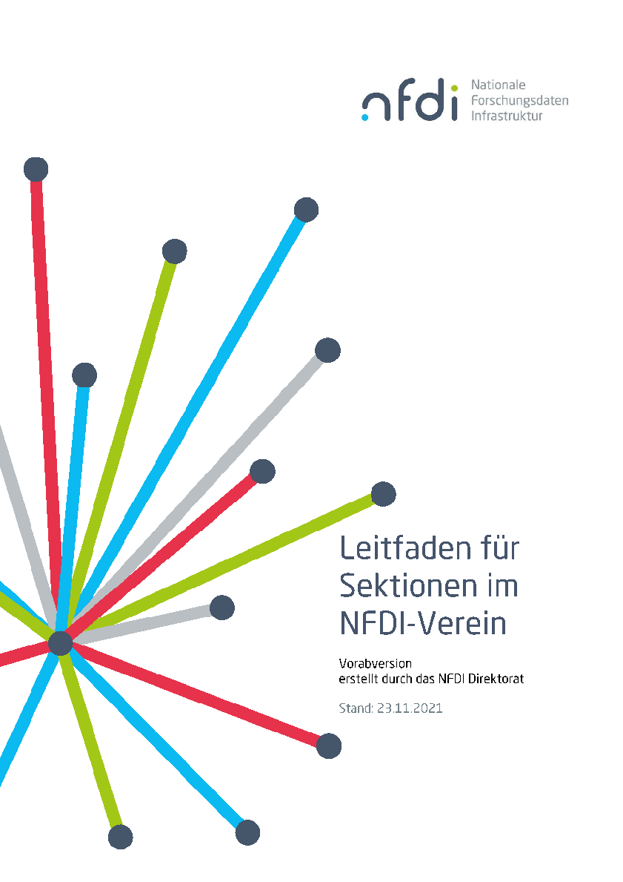

Section
(Meta)data, Terminology,
Provenance

Template
Working Group Charter

Working Group Charter
< WG name >
Version 0.x, 6.12.2021

1. Motivation
(Motivation must derive from at least one of the section’s topic area)

2. Objectives
(Concrete description of expected results)

3. Work Plan
(Work plan with milestone descriptions)

4. Initial Membership List
(At least 6 members from different institutions and at least 6 consortia)

 | Name | Institution | NFDI consortia
1 | Jane Doe (co-spoke) | Universität Pellworm | NFDI4...
2
3
4
5
6
...

5. Adoption Plan
(Descriptions how the participating consortia plan to apply the expected results)

